# 1.Team Members

Keran Wang (keranw 686976)

Xue Jiang (jiangx2 665401)

# 2.Application Overview

## 2.1 Description

Online shopping is a kind of enterprise system which provides a platform for both the business users and the individual users to manage resources, buy and sell commodities, and complete transactions through the Internet. It is developed and operated by business companies with profit motivation.

In the online shopping system, a user can have a role of either the administrator or the registered user. The administrator account which is used to manage other registered user accounts can only be owned by the employees of the operating company. For the registered user account, which is registered by the other individual or business user, there are two types of account, the seller and the buyer. To be specific, only the seller account can sell goods, and the buyer account is only used to purchase goods.

## 2.2 Enterprise System Properties

### 2.2.1 Persistent Data

Data such as the user login name and transaction records will be stored in the database permanently. These data will not be accessed or changed frequently, and will be consistent between the operations.

### 2.2.2 A lot of Data

The online shopping system records millions of information about the goods and transactions. Moreover, in order to manage efficiently, the data will be stored in the database for future use by the users.

### 2.2.3 Concurrent Access

It is possible that many users login or purchase at the same time if the online shopping system is famous. This will lead to the concurrent access to the online shopping system.

### 2.2.4 Many UI Screens

One kind of the critical data type is “item”, buyers need pages to view the item information, sellers need pages to edit the information, and the administrators also need pages to manage the items.

### 2.2.5 Complex Business Logic

There should be some complex logic in an online shopping system as purchase and refund. If a buyer is satisfied with the item he or she has got, the thing goes smooth. However, it needs a complex logic flow to be impartial if there is an argue between buyer and seller.

The following picture might be the workflow of an online shopping system, and it is still incomplete. I think the complete one should be more complex.

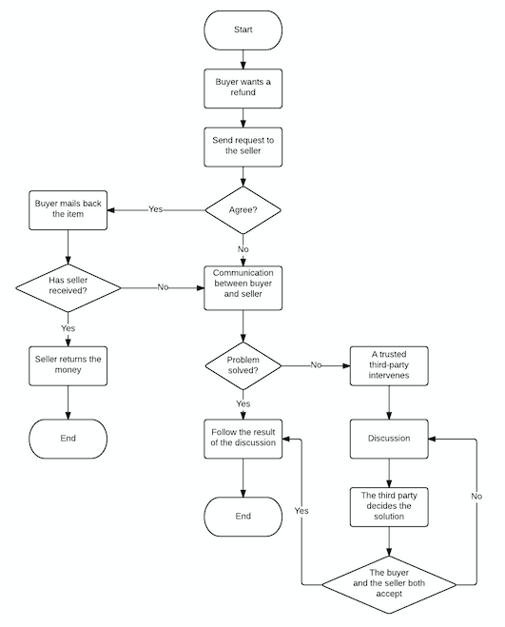

**Image 2.1 Refund workflow**

# 3.Feature Specification

## 3.1 Description

One of the features we want to implement is item management. If a user has registered as a seller, he or she should be able to submit information about the goods he or she wants to sell to the system.

### 3.1.1 Create

There will be a table called items to save the information about the items. As a seller publish a new item on the system, the system will create a new record and save it in the database.

### 3.1.2 Retrieve

If the seller wants to check what items he or she has put in the system, the seller should be able collect the information of the items belong to the user from the database, and show the result on the page.

### 3.1.3 Update

As the seller needs to update some information of an item, the seller should be able to save the change in the database

### 3.1.4 Delete

Once a seller decides not to sale an item he or she has put in the system any more, the seller should be able to delete that record.

## 3.2 Use Cases

### 3.2.1 ItemCreate

|  |  |
| --- | --- |
| ID | IM01 |
| Description | A seller should able to submit a new item for sale |
| Precondition | The user has already registered as a seller and logged in |
| Basic flow | 1. A user click “Add a new item” button on the management page  2. The system shows the form to collect necessary information  3. The user fills in the form and click submit button  4. The system saves the record in the database  5. The system returns to the management page |
| Alternative flow | 3a. The user abandons and clicks “Cancel” button  3a1. The system returns to the management page  4a. The system finds that critical information is missing or incorrect and refuse to save  4a1. The system stays on the information collecting page |
| Postcondition | A new record saved in the database |

### 3.2.2 ItemRetrieve

|  |  |
| --- | --- |
| ID | IM02 |
| Description | A seller should be able to check the item information |
| Precondition | The user has logged in the system and created at least a piece of item record |
| Basic flow | 1. A user clicks the item exists in the list on the management page  2. The system shows the detail information about the item. |
| Alternative flow | None |
| Postcondition | None |

### 3.2.3 ItemUpdate

|  |  |
| --- | --- |
| ID | IM03 |
| Description | A seller should be able to update the information of items |
| Preconditioin | The user has logged in the system and created at least a piece of item record |
| Basic flow | 1. A user clicks the “Update” button of an item  2. The system shows the update page with the information of the item  3. The user update the information and clicks “Submit” button  4. The system saves the changes in the database  5. The system returns to the management page |
| Alternative flow | 3a. The user abandons the change and clicks “Cancel” button  3a1. The system returns to management page  4a. The system finds that the critical information is missing or incorrect and refuses to save the change.  4a1. The system stays on the information collecting page |
| Postcondition | None |

### 3.2.4 ItemDelete

|  |  |
| --- | --- |
| ID | IM04 |
| Description | A seller should be able to delete the item he or she doesn’t want to sell anymore |
| Precondition | The user has logged in the system and created at least a piece of item record |
| Basic flow | 1. A user clicks the “Delete” button of an item  2. The system pops up a confirm window  3. The user clicks “Yes” button  4. The system closes the pop-up and deletes that record from the database  5. The system refreshes the management page |
| Alternative flow | 3a. The user clicks “No” button  3a1. The system closes the pop-up and returns to the management page |
| Postcondition | A record is deleted from the database |